**Project Design Phase**

**Solution Architecture**

|  |  |
| --- | --- |
| Date | 27 June 2025 |
| Team ID | LTVIP2025TMID32415 |
| Project Name | Poultry Disease Classification using Transfer Learning |
| Maximum Marks | 4 Marks |

### Solution Architecture:

Solution architecture is a critical process that bridges the gap between the poultry farming business problem and our AI-based technological solution. Its goals are to:

* Find the best AI solution to detect and classify poultry diseases accurately.
* Describe the structure, behavior, and interaction between the machine learning model, web interface, and user system.
* Define the core features like image upload, prediction, and remedy suggestions, as well as development phases like model training, deployment, and updates.
* Provide clear specifications for deploying the system on cloud/web to make it accessible to farmers.

**Example - Solution Architecture Diagram:**

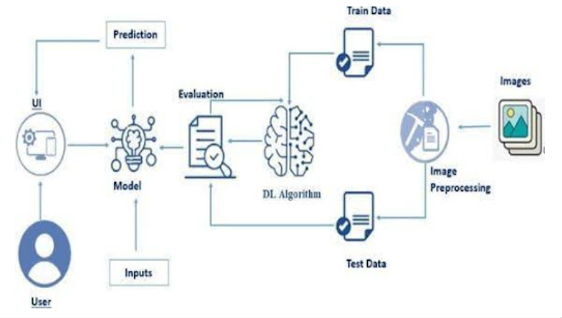

*Figure 1: Architecture and data flow of the voice patient diary sample application*